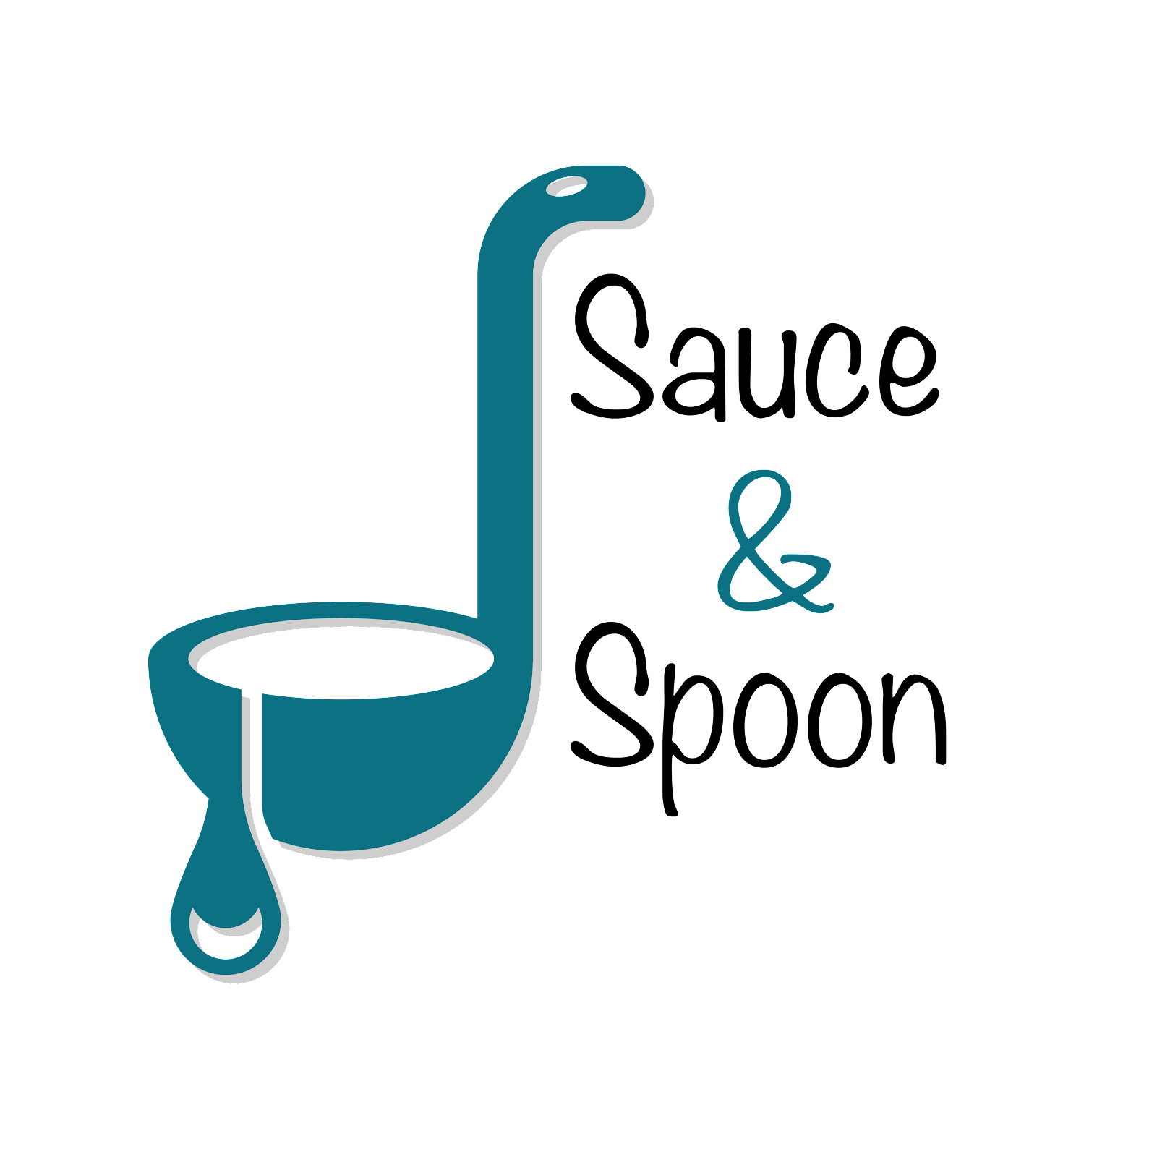

Project Charter: Sauce & Spoon Tablet Rollout

DATE: [02/15/20]

| **Project Summary** |
| --- |
| We plan to launch a pilot rollout of tabletop tablet menus at two of Sauce & Spoon’s five locations. This will speed up service, and allow us to turn tables more quickly and serve more guests. Additionally, it will give us clear data points to track metrics so that we can help ensure the restaurant’s success. |

.

| **Project Goals** |
| --- |
| ***SMART: S****pecific,* ***M****easurable,* ***A****ttainable,* ***R****elevant, and* ***T****ime-bound*   * Increase average daily guest count by 10% by EOY. * Decrease average table turn time by approximately 30 minutes by EOY. * Decrease customer checkout time by 10% on average in the first six weeks after implementation. * Increase sale of appetizers by TBD% by EOY. * Decrease in labor costs by 5% by EOY. * Decrease in food waste and send-back comps by 50% by EOY.. * 95% customer satisfaction in the pilot phase. * <5% technical issues reported by customers in six months. |

| **Deliverables** |
| --- |
| * Installation of working tablets in the bar area at two restaurant locations * Promotion of specific menu items as add-ons, displaying coupons for those items * Integration with current Point of Sale (POS) and Host systems * Upgrade of wiring, electrical, and WiFi systems * Training of management, FOH staff, and BOH staff * Hiring of additional staff (e.g., expediter, BOH staff, IT support staff) per location, as necessary * Purchase of additional operational supplies per location, as necessary * Promotion of tablet menu pilot via table signs and email blasts * Implementation of post-dining survey to assess customer satisfaction |

| **Scope and Exclusion** |
| --- |
| **In-Scope:** Tablet implementation, hiring additional staff, purchase of operational supplies, upgrade wiring and WiFi system, marketing promotion, post-dining survey implementation  **Out-of-Scope:** Order returns policy changes, improving kitchen staff satisfaction |

| **Benefits & Costs** |
| --- |
| **Benefits**   1. Improve service times, leading to happier customers 2. Improve rate of correct orders, leading to happier customers 3. Serve more guests, increase total revenue 4. Reduce food waste   **Costs:**   * Training materials and fees ($10,000) * Hardware and software implementation ($30,000 * IT fees/Maintenance ($5,000) * Updated website and menu design ($5,000) * Customization ($550)   **Budget needed:**   * $50,550 |

| **Appendix:** |
| --- |
| **Misalignments and Decisions:**   * Misalignment: The team has agreed that a policy change to order returns is an inherent aspect of the project charter and necessary if tablets will be used   + Decision: Policy changes are not necessarily tied to this project and in need of further discussion as an operations item. Changes on order returns will be handled outside of tablet project rollout. * Misalignment: Policy adjustments on order returns and meal replacements should be part of the project charter.   + Decision: Policy changes on order returns will be handled outside of tablet project rollout. * Misalignment: There should be a goal in the project charter for improving satisfaction of kitchen staff   + Decision: Will not be included until there is an agreed upon way to measure it * Misalignment: Food waste is the main reason for a need to look at food return policy   + Decision: Food waste is part of the issue, but also kitchen staff performs poorly against busy times coupled with food returns. The food waste goal will be adjusted to better capture kitchen staff’s performance. |